Karel assignment

we have to divide the Karel world into 4 x 4

* The inner chambers should be the biggest possible squares
* The outer chamber should be equal in size, and they be L-shaped

The first thing is (way of my thinking) to calculate the area of the world

and to get the inner chamber the biggest possible equals squares,

the number of columns (y-axis) should not be taller than the number of rows (x-axis).

I made a function to calculate the area, by letting the Karel move from the start till the end of x-axis (frontIsClear) then turn left and count the Y-axis

Then I mad a function to make a cross lines in middle of rows and Columns

To make the cross lines exactly in the middle of Karel world, I have to make a double line if one of Y and X is even and its looks like this:

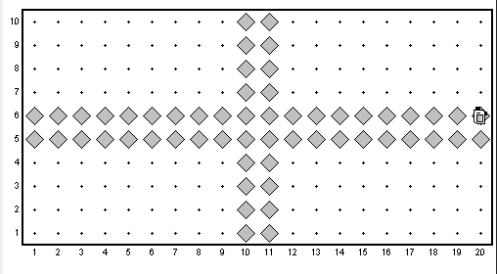

And the final step is to make a square, and the dimensions of the square are Y/2 -1 to make it looks like a square and start to draw it

And this is the final looking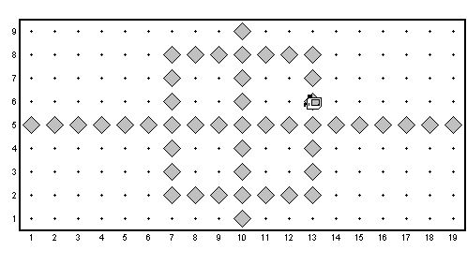

Omar Mohsin

Karel Assginment